**Task 2: Test log**

|  |  |  |  |  |  |
| --- | --- | --- | --- | --- | --- |
| **Test No.** | **Description of test** | **Test data to be used (if required)** | **Expected outcome** | **Actual outcome** | **Comments and intended actions** |
| 001 | Testing if the website runs and loads into the home page. (Normal Test) | N/A | The website should load and launch into the index (home) page. | The website launches as intended and no errors were identified. See Screenshot 1 | Works as intended |
| 002 | Testing to see if the cookies show up when the user first loads up the website | N/A | The cookies should appear to the user asking whether to accept or decline the cookies. | The cookies show up when the user loads into the website for the first time.  See screenshot 2 | Works as intended |
| 003 | Testing if the register button on the home page functions as intended. | N/A | The website should load and launch into the registration page. | The website launches as intended and no errors were identified. See Screenshot 3 | Works as intended |
| 004 | Testing to see if the full name will be accepted.  (Normal test) | Jon Jones | It should allow the full name to work and register. | It should allow me to now enter in my email address.  See screenshot 4 | Works as intended |
| 005 | Testing to see if it asks me to enter in the field when left blank (Erroneous Test) | Full Name = null | It should ask me to enter information into the field | If the user leaves the full name blank and tries to move on or submit the form then it will ask to first enter some information.  into that field. See screenshot 5 | N/A |
| 006 | Testing to see if letters and symbols will be allowed for the Full Name (Erroneous Test) | Jon Jones1234@!? | It should say no numbers and symbols are allowed. | It allowed for the user to enter in numbers and symbols which needs to be fixed, it displayed no message at all. See screenshot 6 | This seems to be a validation error as for the full name field there should be letters only and no symbols and numbers with the letters. To overcome this I need to check the HTML and see what is wrong with the code.  As seen in screenshot 6.1 it wasn’t linking back to the name since the name was wrong and couldn’t link, I will change it to the right name which will be ‘invalidName’. Will now need to fix the issue which can be seen in screenshot 6.2 |
| 007 | Retest - Testing an invalid input into the Name field of the register page. (Erroneous test) | Jon Jones1234@!? | It should say no numbers and symbols are allowed. | After fixing the issue in the previous test, It is now working correctly since it says to the user that no numbers and characters are allowed as it should be doing. See screenshot 7. | RESOLVED – N/A |
| 008 | Testing input into the email field of the registration page. (Normal Test) | Jonjones2@gmail.com | No error messages should display, and the website should allow the entry. | The email field accepts the input and allows the user to move to the password entry. See Screenshot 8. | N/A |
| 009 | Testing an invalid input into the email field of the login page.  (Erroneous test) | Jonjones2 | Validation rules should alert the user that their email must contain an ‘@’ symbol and have a domain to continue. | The website allowed the user to enter the invalid email address, as seen in Screenshot 9, it displayed no error, warning message at all. | To overcome this, I will check the HTML form and the input type for this field.    As seen in screenshot 9.1 a potential cause of the problem has been found within the ‘type’ of the user entry. I will change this ‘type’ to email.  (Screenshot 9.2) and re-test the website.  Have now included an example for the user. See screenshot 9.3. |
| 010 | Retest - Testing an invalid input into the email field of the login page. (Erroneous test) | Jonjones2 | Validation rules should alert the user that their email must contain an ‘@’ symbol and have a domain to continue. | After fixing the issue in the previous test, the validation is now correctly working and highlights that there is no ‘@’ symbol in the email, as it should be doing. See Screenshot 10. | RESOLVED – N/A |
| 011 | Testing registration page email field if it accepts blank after the @ symbol (Extreme testing) | jonjones2@ | Upon entry of the test data the field should show an error message as the email requirements aren’t met in this specific test data. | The fields validation functions as it should and shows the user that they still must enter in an email address as shown in screenshot 11. | N/A |
| 012 | Testing the register page email field to see if it accepts an email which meet the length requirements (Normal testing) | jonjones2@gmail.com | The field should accept this email without an error message as it meets the validation. | The validation works correctly, by allowing the input of the email without showing any errors.  See screenshot 12 | N/A |
| 013 | Testing the registration page password field for a password that is under the specified length which is 8 characters (Normal testing) | Jones | Upon entry of the test data the field should show an error message as the password requirements aren’t met in this specific test data. | The fields validation functions as it should and shows the user an appropriate error message as shown in screenshot 13. | N/A |
| 014 | Testing the register page password field to see if accepts passwords which meet the length requirements (Normal testing) | Jones786! | The field should accept this password without an error message as it meets the minimum 8character validation. | The validation works correctly, by allowing the input of this password without showing any errors.  See screenshot 14 | N/A |
| 015 | Testing the register page password field to see if accepts a blank password (Erroneous testing) | Password = null | The field should not accept this password and it should ask the user to enter in their password. | The website asks the user to enter in their password when the password field is left blank. See screenshot 15 | N/A |
| 016 | Testing the register page password field to see if accepts past the character limit which is 128 by entering in 200+ words (Extreme testing) | jones jones jones jones jones jones jones jones jones jones jones jones jones jones jones jomes jones jones jones jones jones jones jones jones jones jones jones jones jones jones jones jomes jones jones jones jones jones jones jones jones jones jones jones | The field should show the user that there is 128/128 words and the character limit should show up red for the user in order to show the user that they have reached the limit | The website shows the user that they have entered 128/128 words as well as the character limit showing up red. See screenshot 15 | N/A |
| 017 |  |  |  |  |  |
| 018 |  |  |  |  |  |
| 019 |  |  |  |  |  |
| 020 |  |  |  |  |  |
| 021 |  |  |  |  |  |
| 022 |  |  |  |  |  |
| 023 |  |  |  |  |  |
| 024 |  |  |  |  |  |
| 025 |  |  |  |  |  |

**Add more rows and tables as required.**

# Screenshot 1

# Screenshot 2

# Screenshot 3

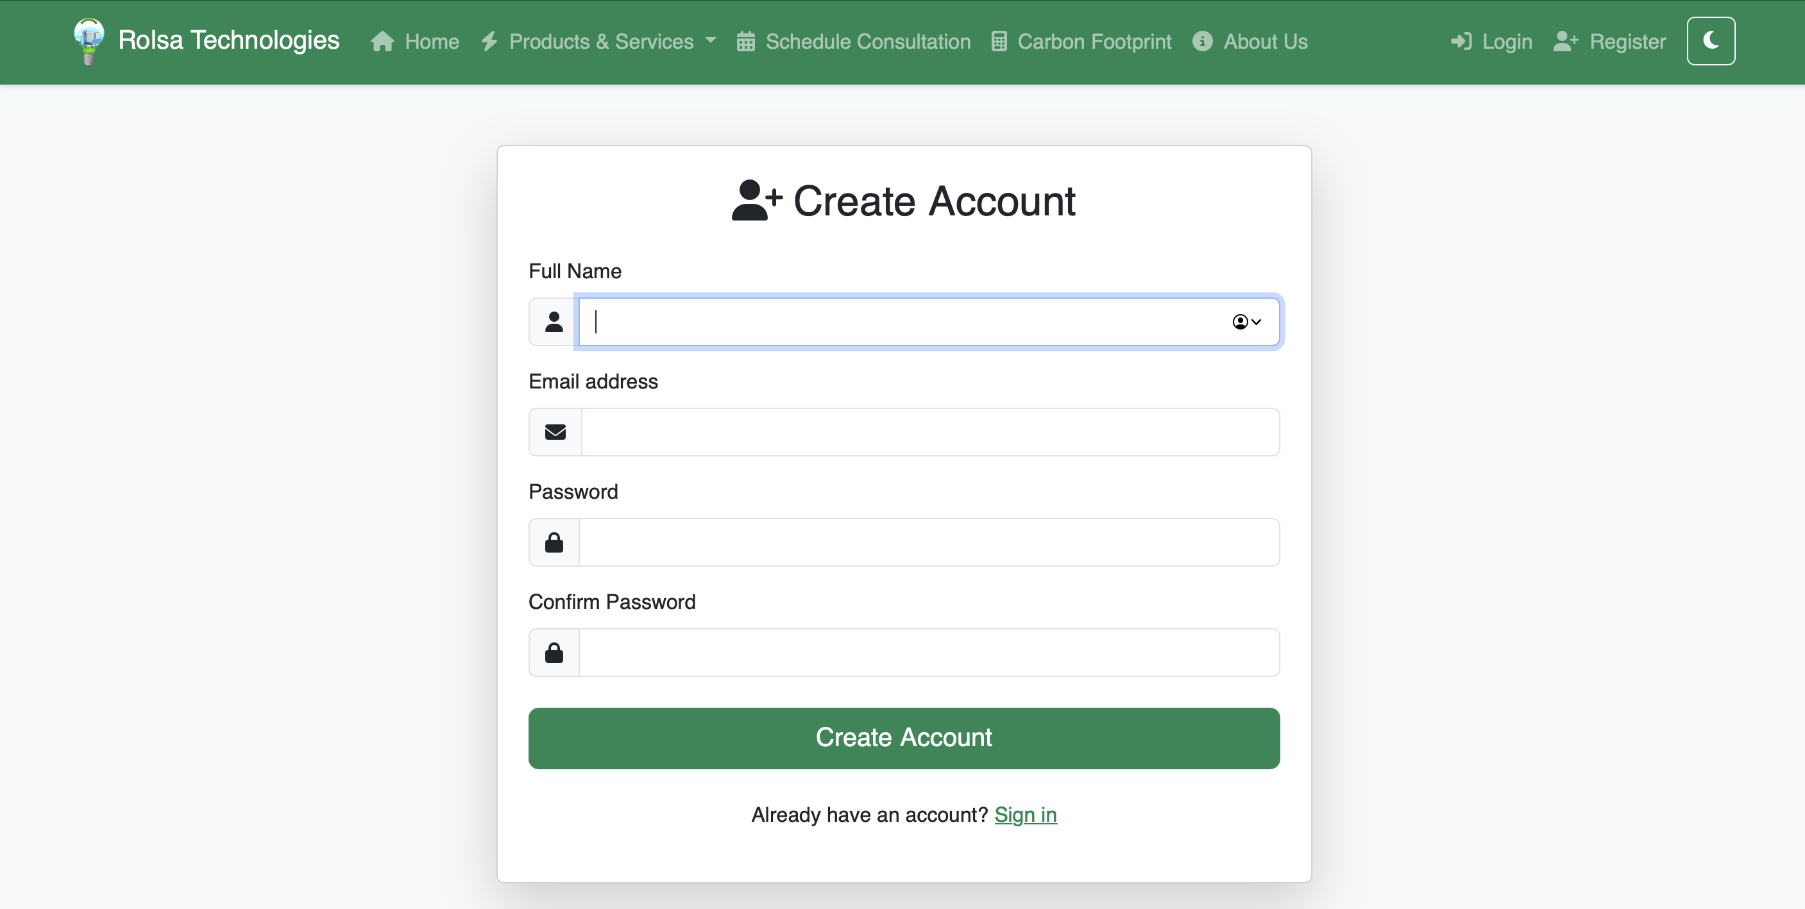

# Screenshot 4

# Screenshot 5

# Screenshot 6

# Screenshot 6.1

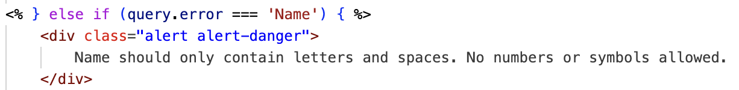

# Screenshot 6.2



# Screenshot 7

# Screenshot 8

# Screenshot 9

# Screenshot 9.1

# 

# Screenshot 9.2

# 

# Screenshot 9.3

# Screenshot 10

# Screenshot 11

# Screenshot 12

# Screenshot 13

# Screenshot 14

# Screenshot 15

# Screenshot 16

# Screenshot 17

# Screenshot 18

# Screenshot 19

# Screenshot 20

# Screenshot 21

# Screenshot 22

# Screenshot 23

# Screenshot 24

# Screenshot 25

# Screenshot 26

# Screenshot 27

# Screenshot 28